**Installing TimberScan**

Before Installing TimberScan, local machines must have a updated version of Crystal Reports and TimberViewer must be installed. They can both in found in the “Workstation Install” by the pathway

JLJ-SAGE -> TimberScan -> Workstation Install

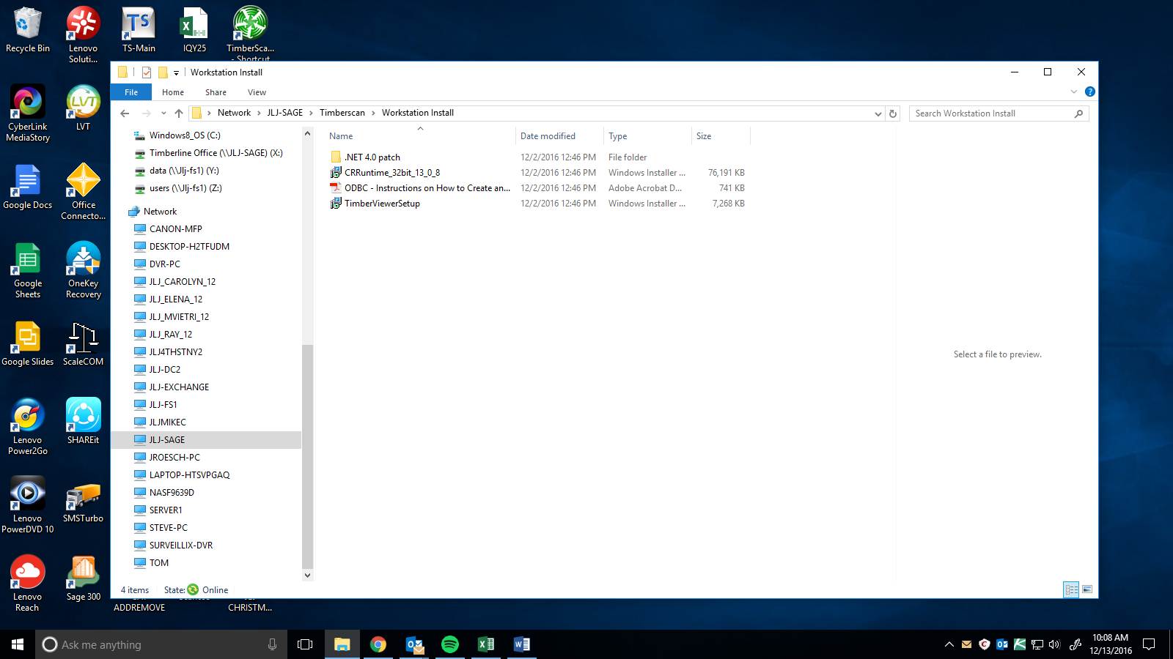



Open up ODBC Data Source Administrator (32-bit) in Windows ( you can find this by searching “ODBC” in the search bar) 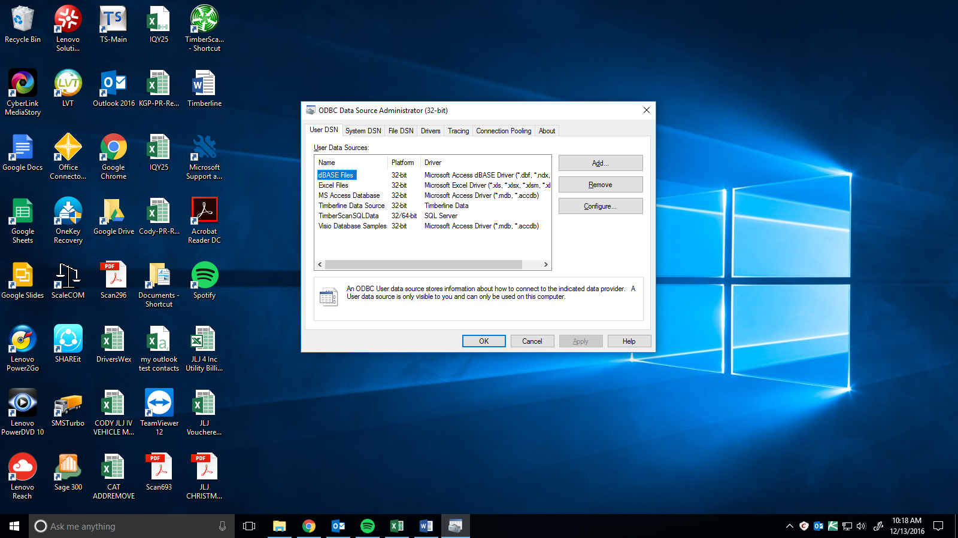

Click “Add” and scroll down in “Create New Data Source” to find “SQL Server” and Click “Finish”

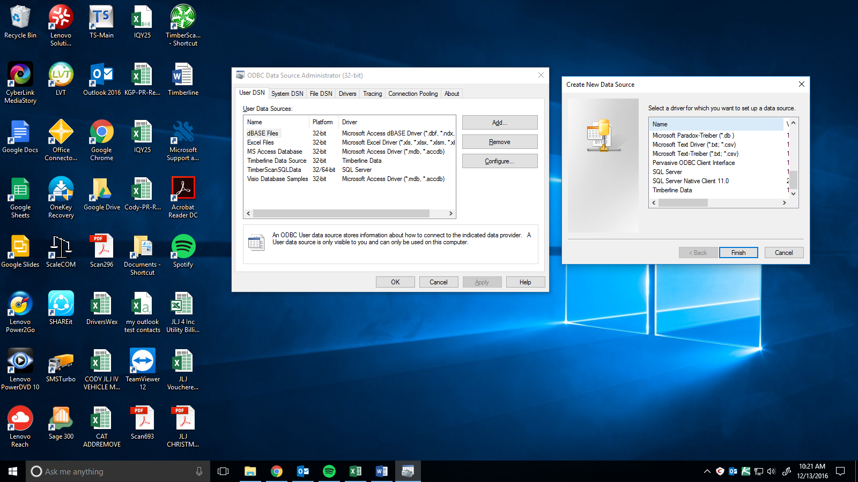



In the “Name” field, enter: TimberScanSQLData ,

then in the “Server” field, enter: JLJ-SAGE\SQLTIMBERSCAN , Click “Next”

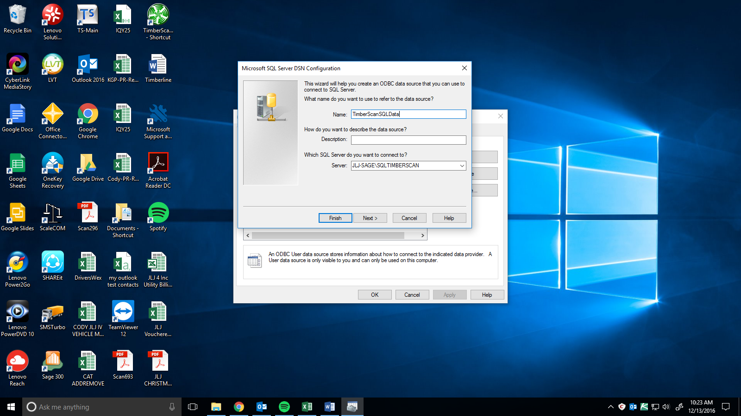



Click “Client Configuration”, In the “Network Libraries” field, choose “named pipes” and click “OK”

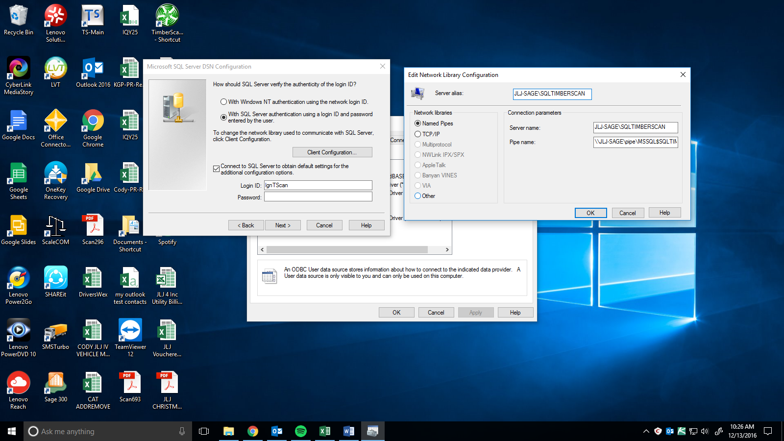



In the SQL Server verify field choose, “With SQL Server authentication using a login ID and password entered by the user.” Use the Login ID: lgnTScan (l is a lowercase L) and Password: 20GDS06 (0 are zeros) , then click “Next”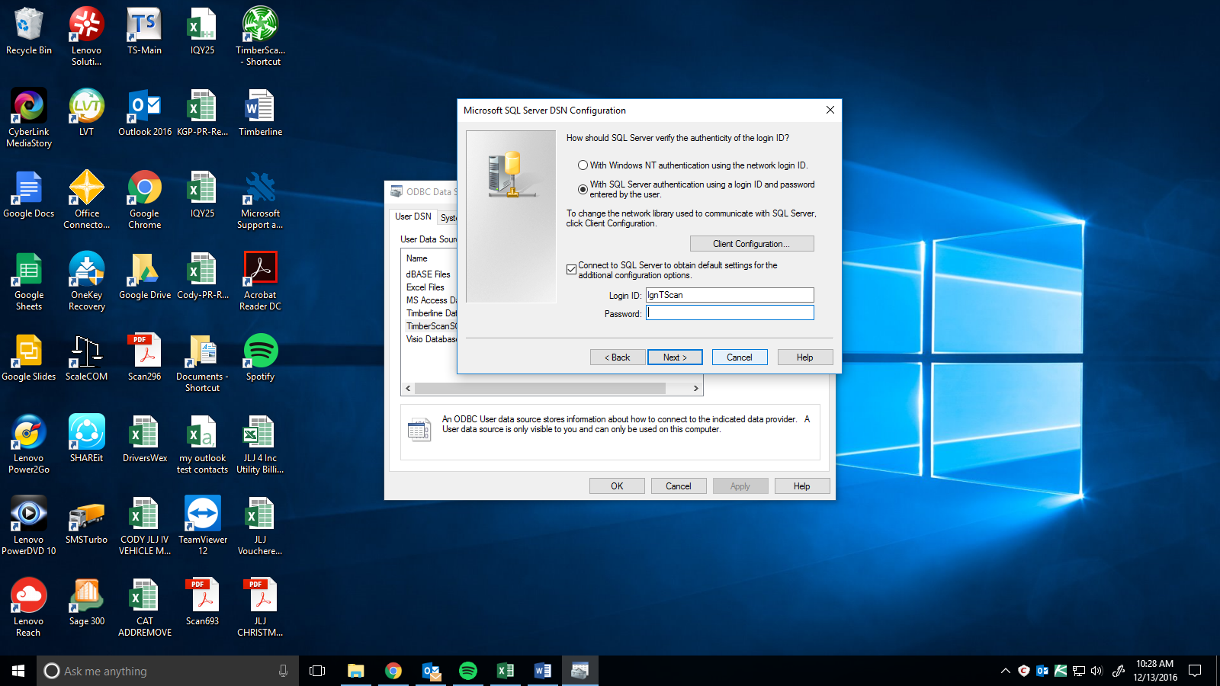



Click “Next”

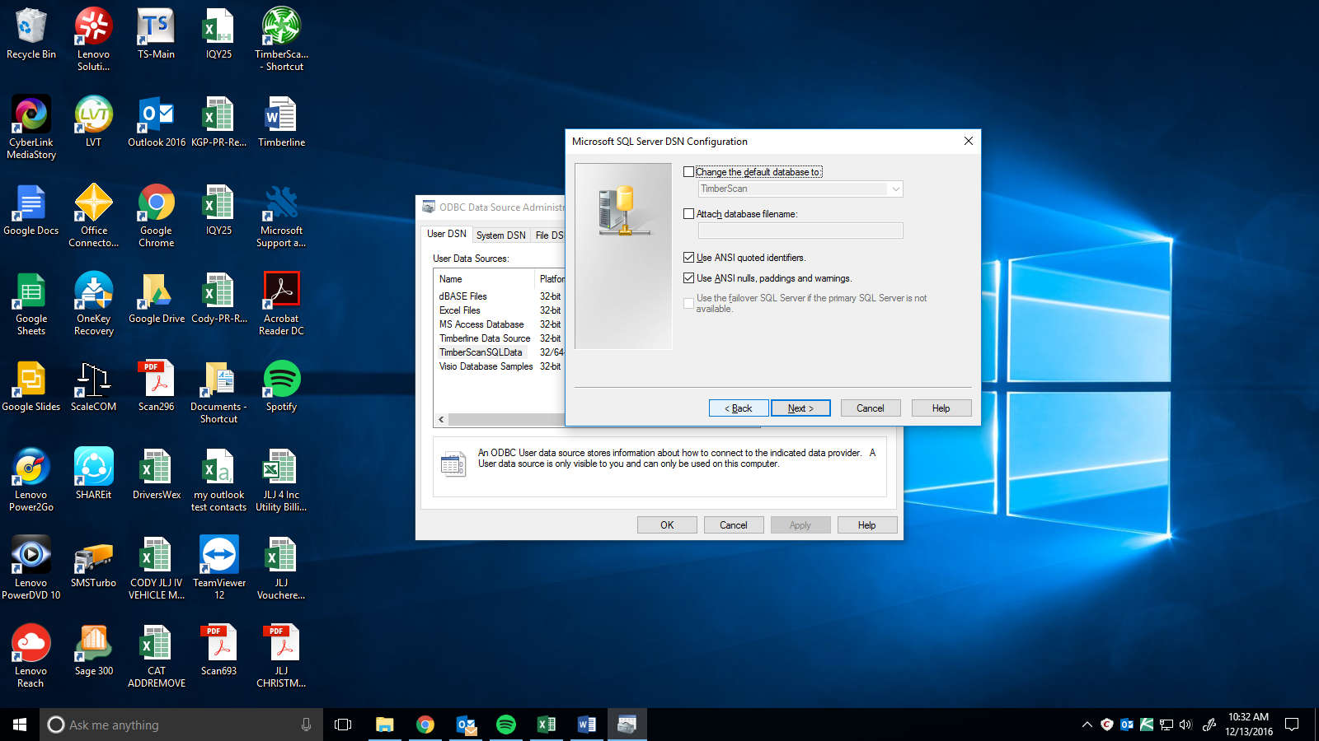



Click “Finish”

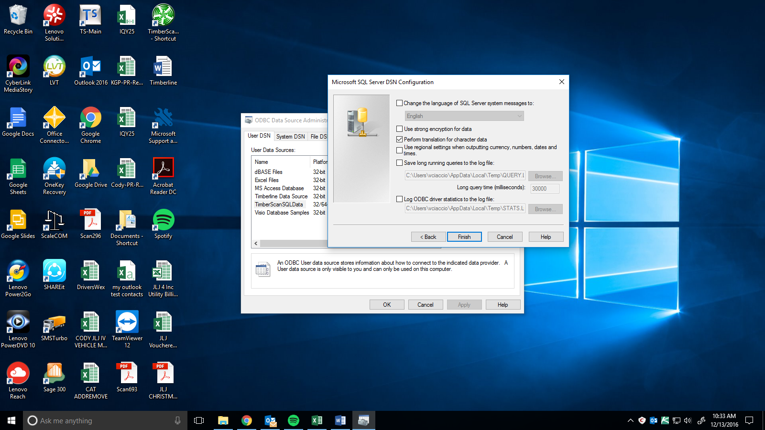



You Should now see “TimberScanSQLData” in the list of “User Data Sources”, Click “OK”

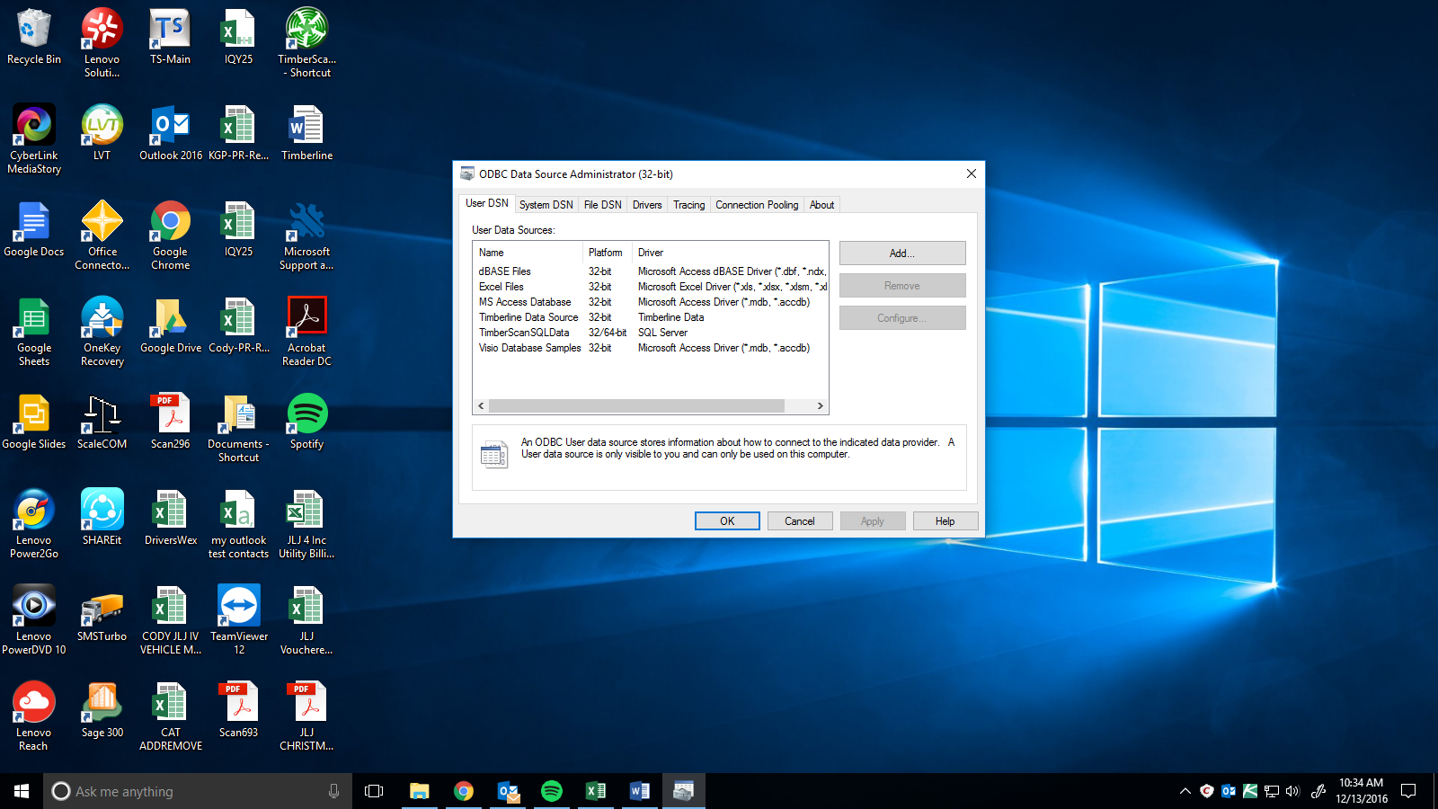



Go to your File Explorer, Follow the path:

JLJ-SAGE -> Timberscan -> Application -> Timberscan.exe

Send it to desktop

And double click “TimberScan”



When seeing the “TimberScan Login” prompt, Enter your User information and once login “Exit” out of TimberScan

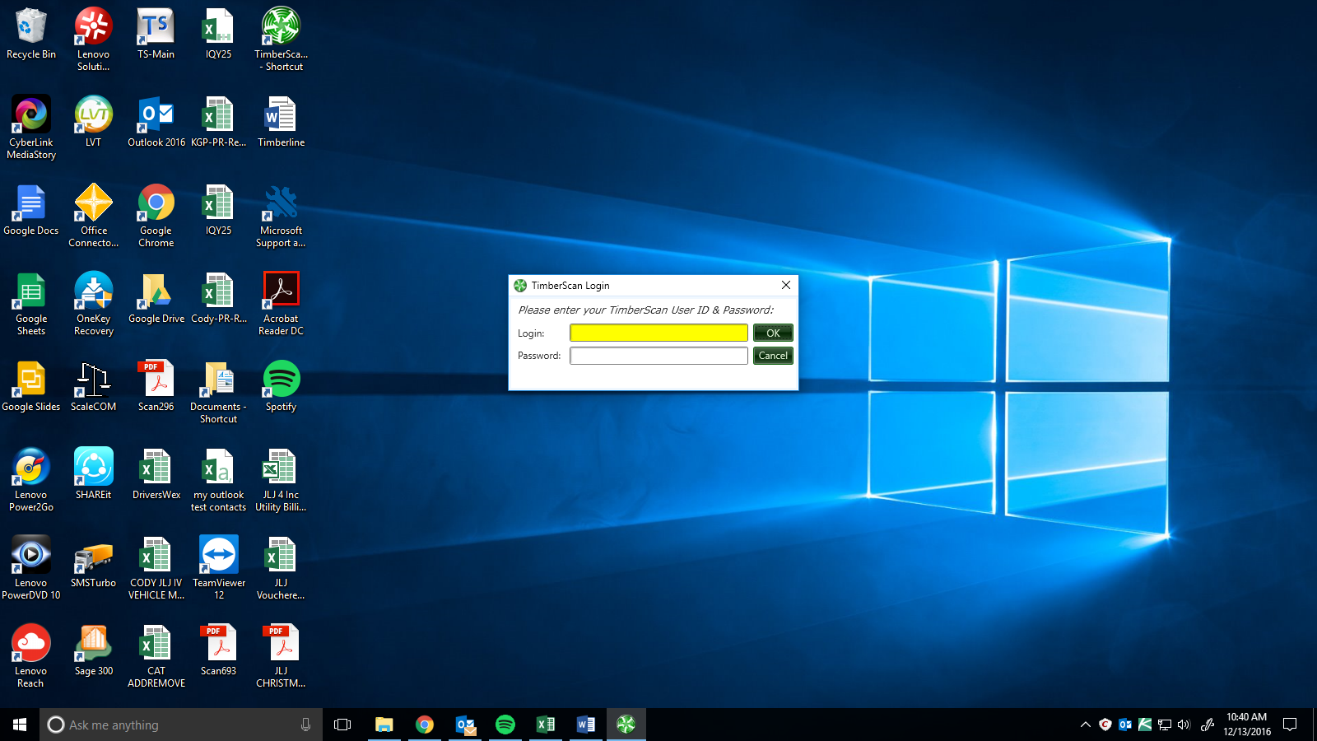

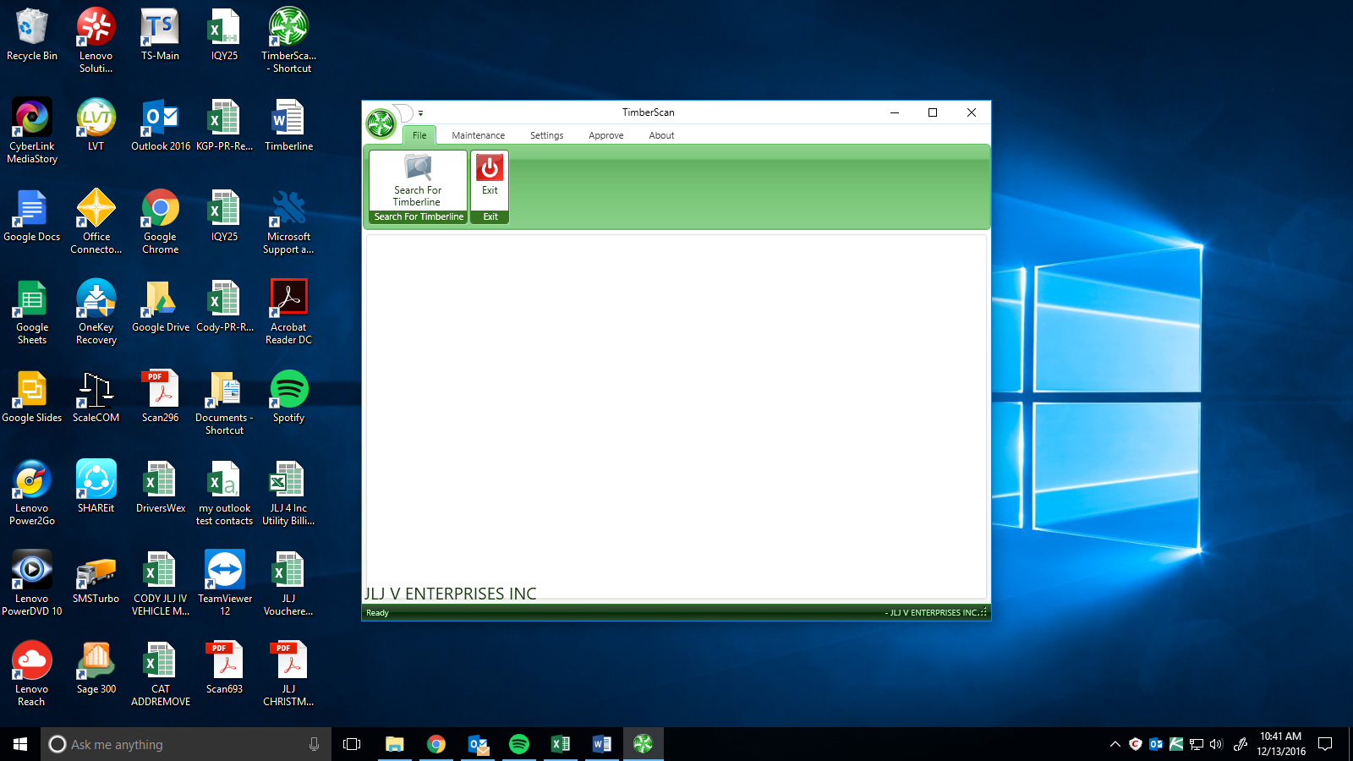



Go back to the File Explorer Location where you ran TimberScan from, right click and add shortcut, then drop it to the Desktop. This is where you will now on access TimberScan.

